STARL (formative)

Kenneth Brown - 40090523

Contents

STARL Example – Project Management 2

Appendix X 4

Appendix Y 4

Appendix Z 5

# STARL Example – Project Management

**Situation**

For this project, the team is developing an educational platform through which fourth year Napier students will be able to practice their Penetration Testing skills in a lab environment. The main goal is to create an **up-to-date** Server environment for pen-testing. Currently, many courses still deploy virtual networks for student learning that use out of date OS versions like Windows Server 2003, which do not reflect real-world scenarios accurately anymore. The team is using a testbed environment which utilises Windows Server 2016 for the target and Kali Linux 2020 for the attacker. Within our server environment we also need to create a vulnerable e-commerce website which can be used to demonstrate various web-based attacks such as SQL Injections (SQLi) or Cross-Site Scripting (XXS).

**Task**

My role within the project is as the ‘Project Manager’, with my primary focus being on keeping clear and manageable goals in place for the team throughout the duration of the project timeline, as well as producing documentation and keeping up regular communications with our client and sponsor. Whilst it is not my role to get too involved with the practical side of the deployment it is still important that I understand the purpose and outcome of each task so that I am able to keep the project focussed and moving in the right direction. The nature of this project dictates that our team should have proficiencies in four key areas, Cyber-Security, Web-Design, Server Management and Network Administration. Keeping all these things in mind and allocating appropriate tasks to each member has proven to be a big challenge for me as this is my first experience managing a team of this size or a project of this scale.

**Action**

To tackle these challenges, I have relied heavily on being able to utilise the various skillsets of the different team members and using the guidelines for Agile Project Development. One of the earliest decisions made was to keep the *initial* scale of the project to a minimum, to guarantee, at least, an acceptable standard of completion for our client. To ensure that the team saw the best results I decided to create separate communication channels in Discord through which we could filter either security-based research, web-based research, and other important topics. This gives the team a quick point of reference for retrieving useful information relating to their own tasks. I have also allocated ‘Team Leader’ roles for both the web and security teams. This was done to create a more controlled flow of information, with the team leaders taking responsibility for their smaller groups’ tasks, allowing me to only need to receive major updates from two or three main sources as opposed to five. Evidence of task allocations and our filtered research channels can be viewed in the form of Discord chat logs in **Appendix X**.

**Result**

Through doing this I was able to contribute to the security research side of the project early in the timeline. This has helped to further the team’s ideas regarding SQLi and XXS. Evidence of this is shown in **Appendix Y**. At the end of the projects first two-week iteration there was also a clear divide in communication, with some members regularly contributing on nearly a daily basis and others waiting until scheduled meetings to deliver their updates. This caused delays with the web side of the project due to some work being repeated by more than one member of the web team, which in turn also delayed the amount of security tasks that could be completed. This issue required me to speak individually to some of the members of my team and discuss communication issues they may have with other members. A contribution channel was also set up on Discord where members must post something they have contributed and something another member has contributed during the last week, done on a weekly basis. Evidence of this is shown in **Appendix Z.** In doing this the group was able to quickly get back on task. This was reflected in the last meeting with the client where the expressed that they were pleased with the progress that has been made so far. **Unfortunately, I cannot provide evidence for this at this time as it was through a video meeting that was not recorded. Full evidence will be provided in my final self-evaluation report in the form of a written acknowledgment from the client or minutes from a future meeting.**

**Learned**

I have learned a great deal about project management through the Agile methodology guidelines (**P3 Express**). Not knowing exactly what tasks need to be carried out ahead of time initially sounded like a major risk, however in applying the methodology effectively, it has been shown to produce good results by allowing the team a great deal of freedom to experiment with ideas and research. By following this structure more closely I believe that the rest of the project can exceed our original expectations and produce great results. I have also learned a great deal about effective communication strategies through our trial-and-error approach taken during the initial phase of the project.

# Appendix X

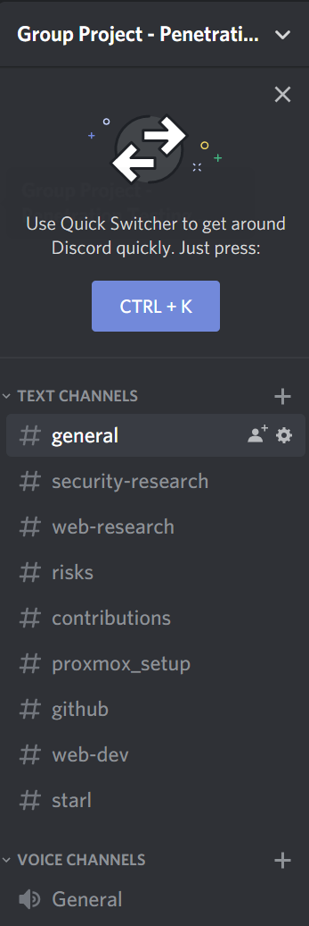 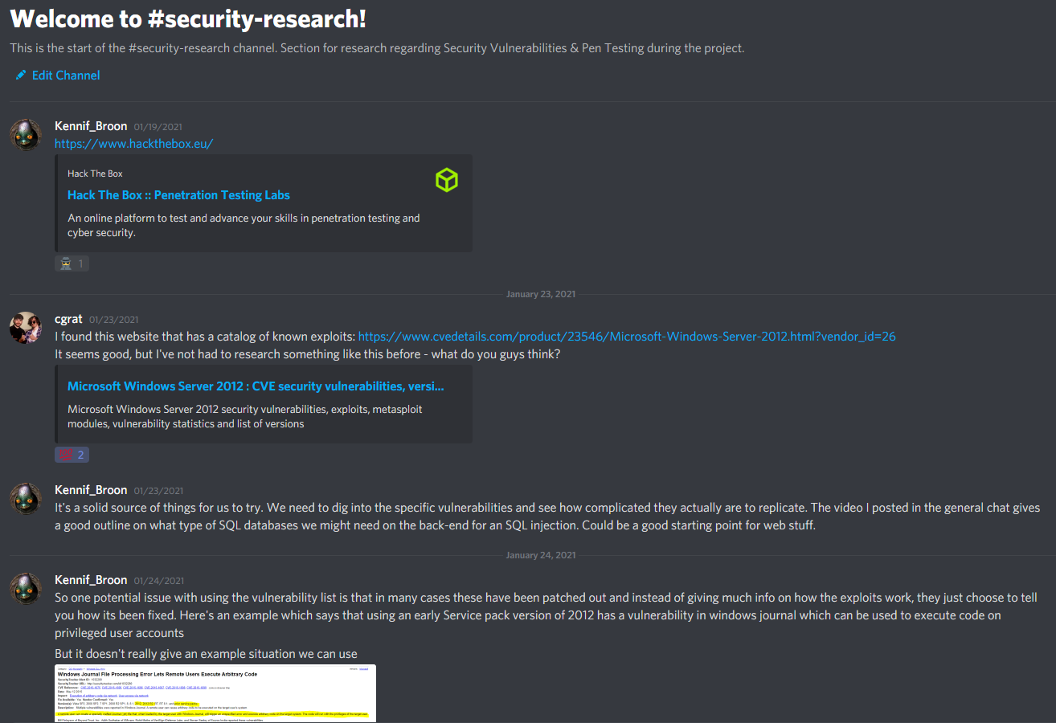

Figure – Evidence showing the various Discord communication channels & an early page from ‘Sec Research’.

# Appendix Y

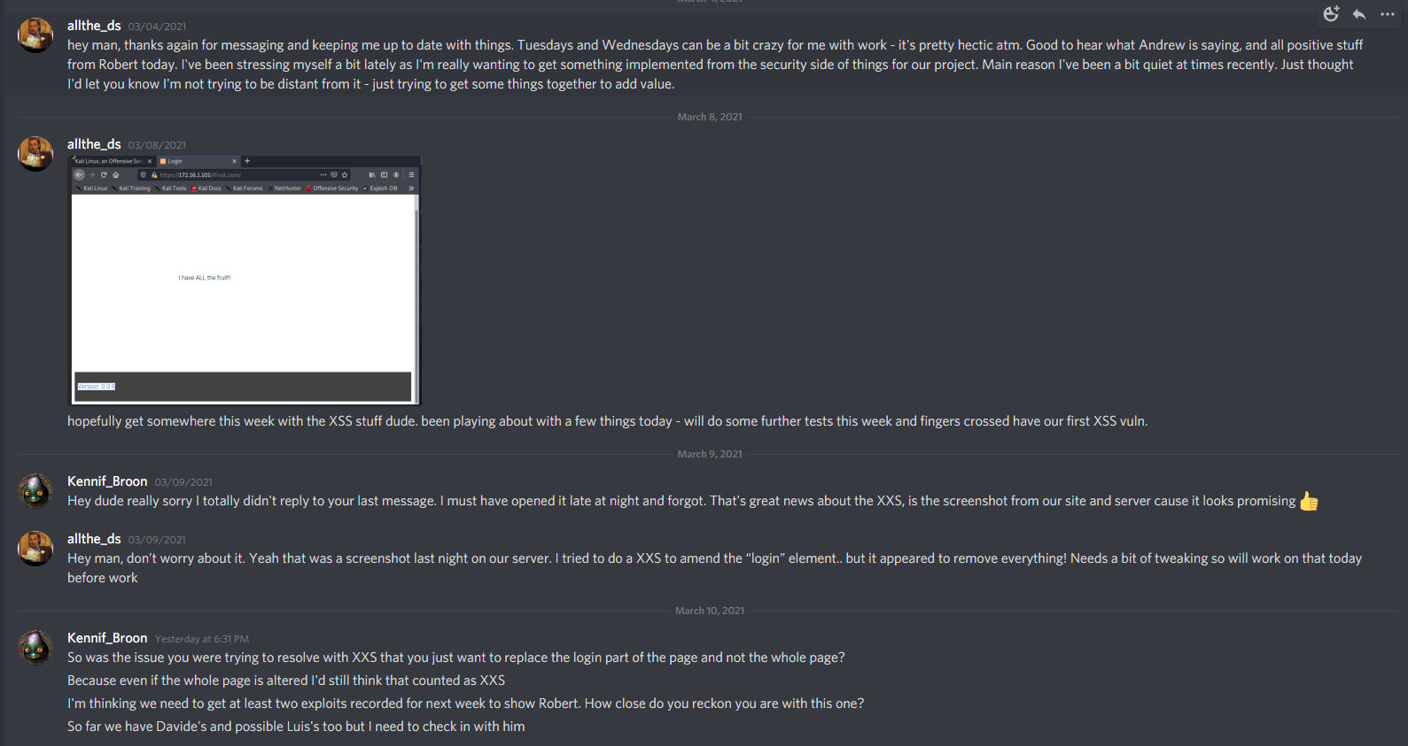

Figure - Evidence - Resolution of Communication Issues

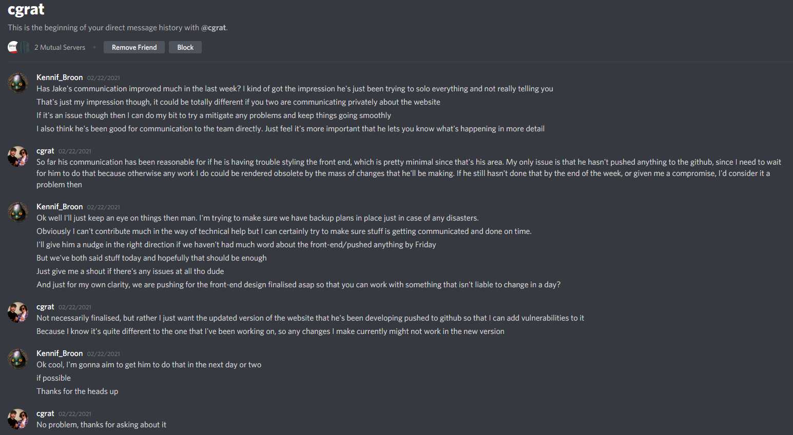

Figure - Evidence - Resolution of Communication Issues

# Appendix Z

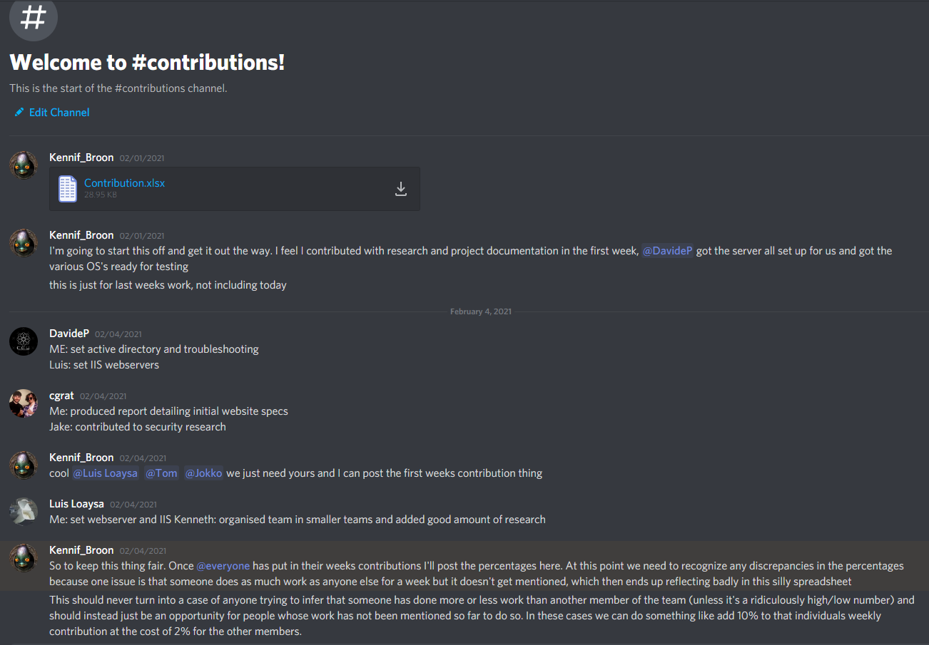

Figure 4 - Excerpt from Contributions Discord Channel Appendix Z